**CSA0492-OPERATING SYSTEM**

**LAB EXERCISES**

**NAME:S.SHASHIKANTH**

**REG.NO:192125026**

1. **Create a new process by invoking the appropriate system call. Get the process identifier of the currently running process and its respective parent using system calls and display the same using a C program.**

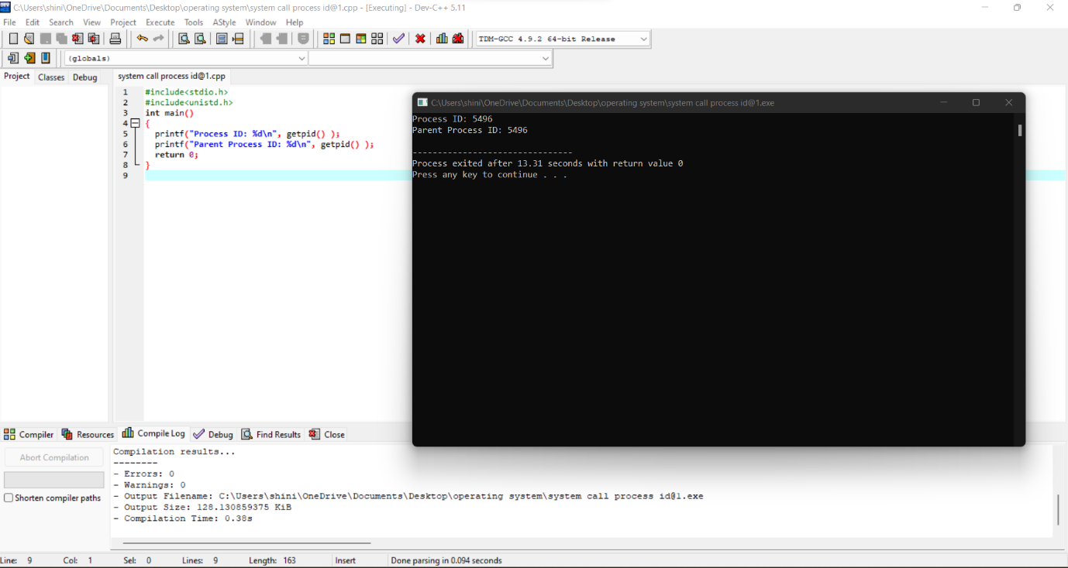

1. **Identify the system calls to copy the content of one file to another and illustrate the same using a C program.**

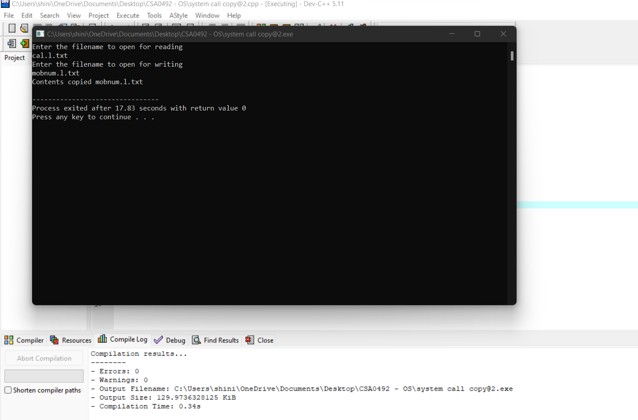

1. **Design a CPU scheduling program with C using First Come First Served technique with the following considerations. a. All processes are activated at time 0. b. Assume that no process waits on I/O devices.**

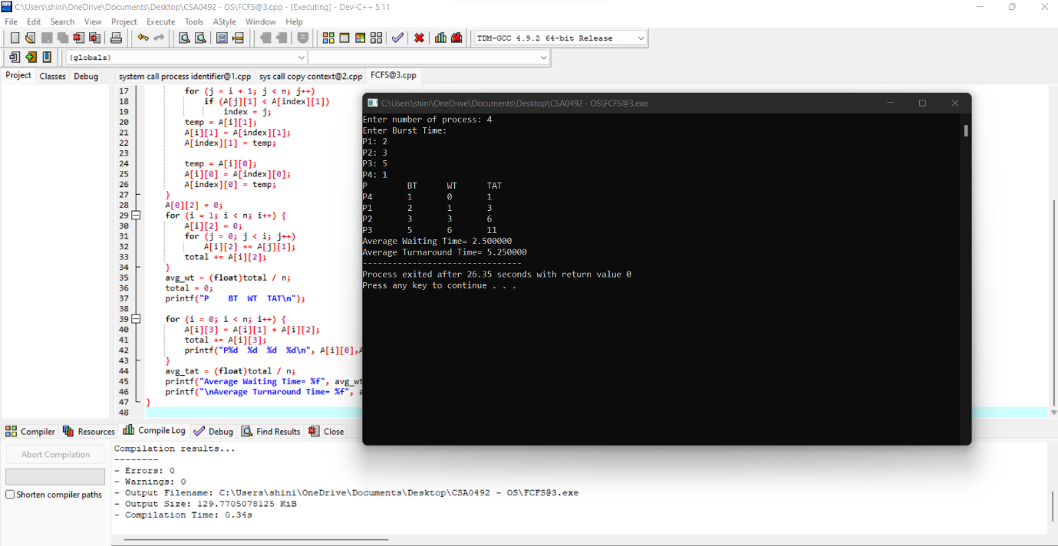

**4.Construct a scheduling program with C that selects the waiting process with the smallest execution time to execute next.**

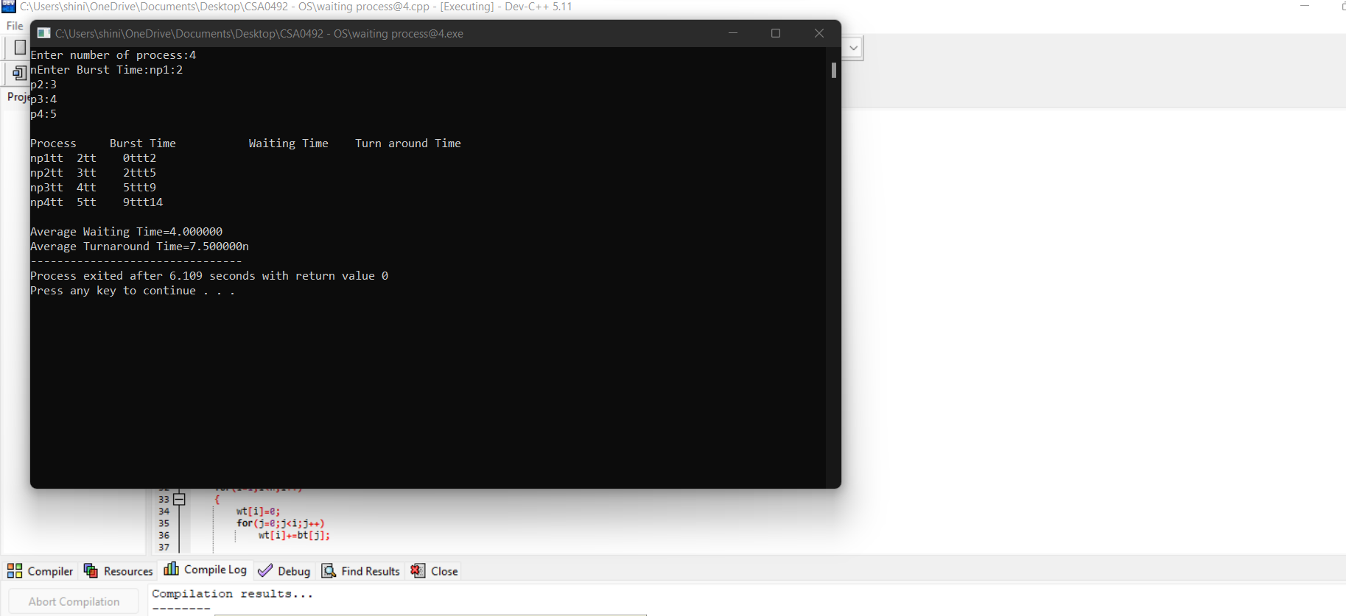

**5.Construct a scheduling program with C that selects the waiting process with the highest priority to execute next.**

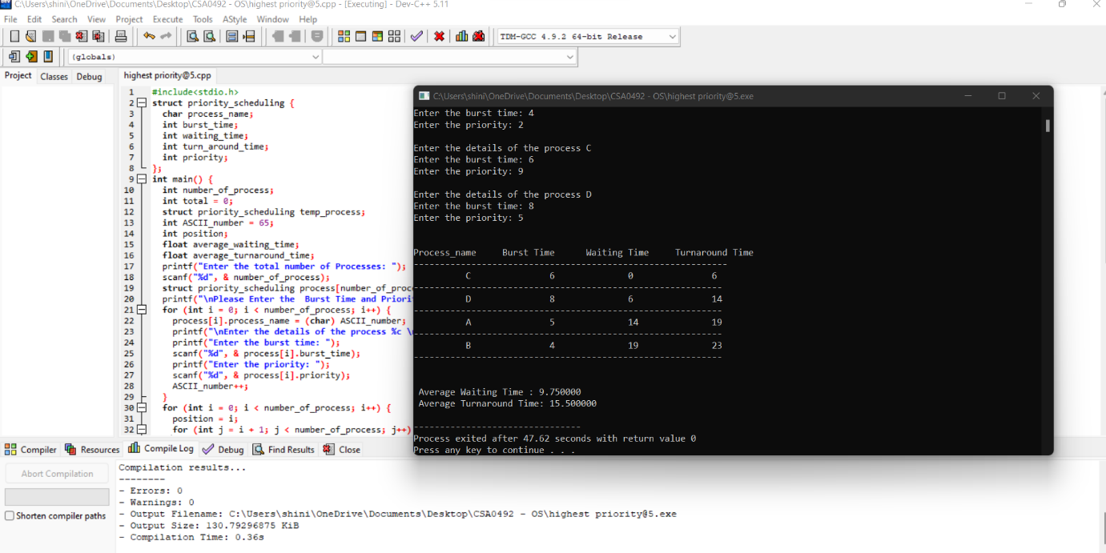

**6.Construct a C program to implement pre-emptive priority scheduling algorithm.**

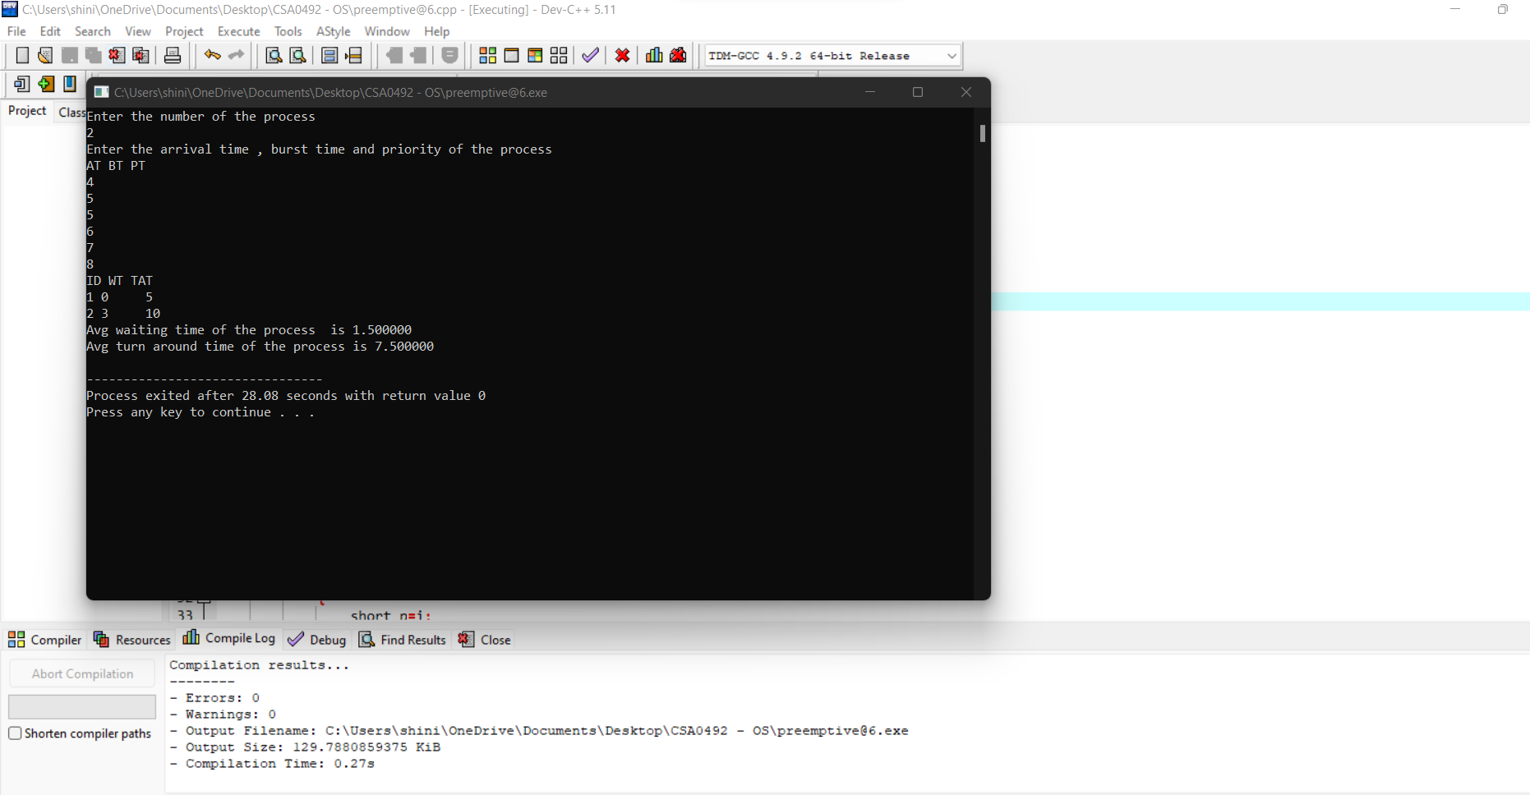

**7.Construct a C program to implement non-preemptive SJF algorithm.**

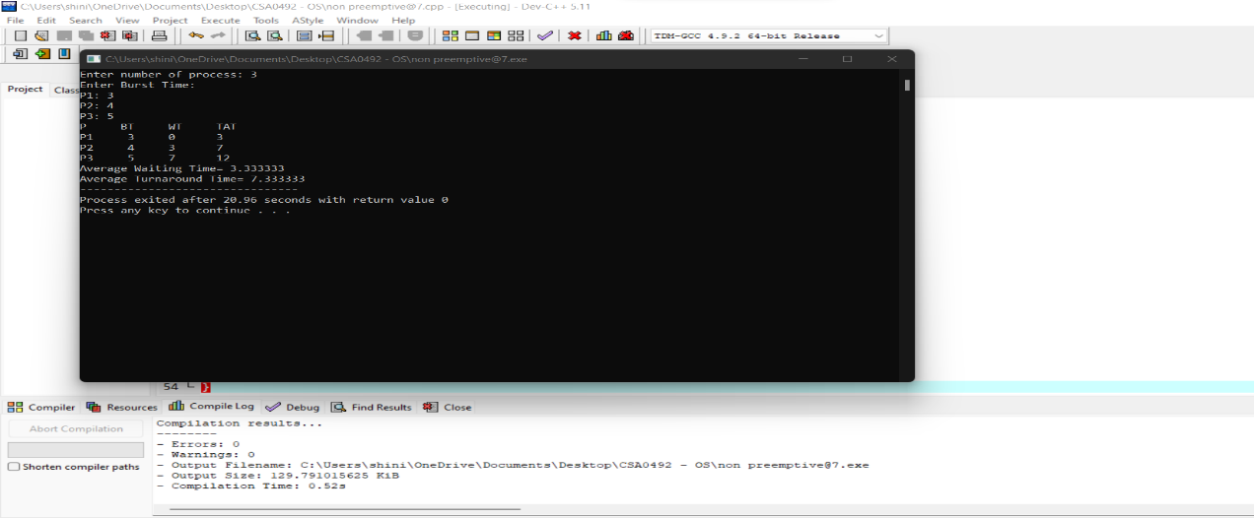

**8.Construct a C program to simulate Round Robin scheduling algorithm with C.**

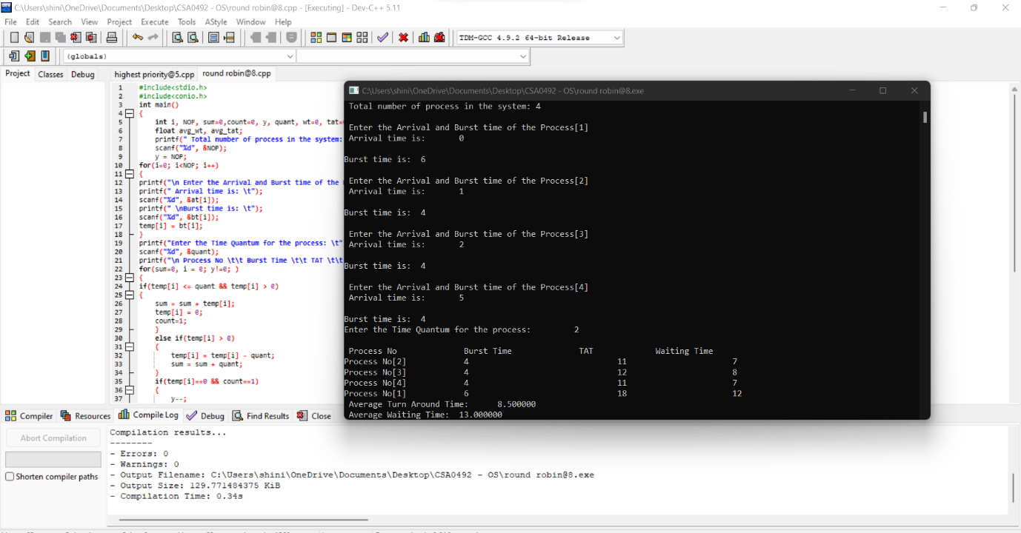

**9.Illustrate the concept of inter-process communication using shared memory with a C program.**

**11.Illustrate the concept of multithreading using a C program**

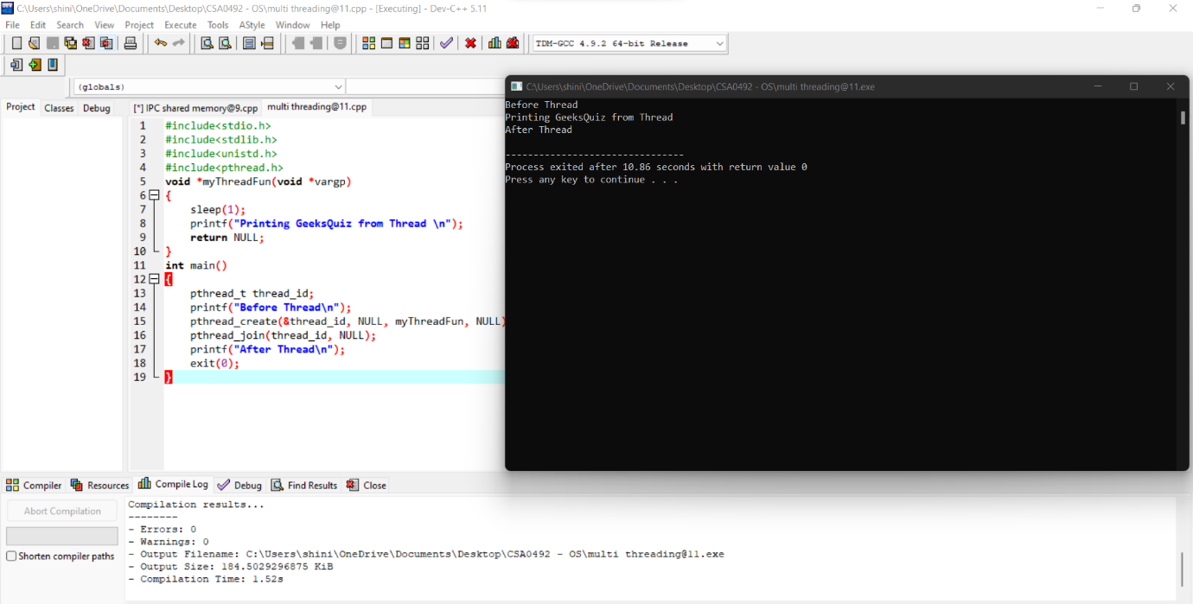

**12.Design a C program to simulate the concept of Dining-Philosophers problem**

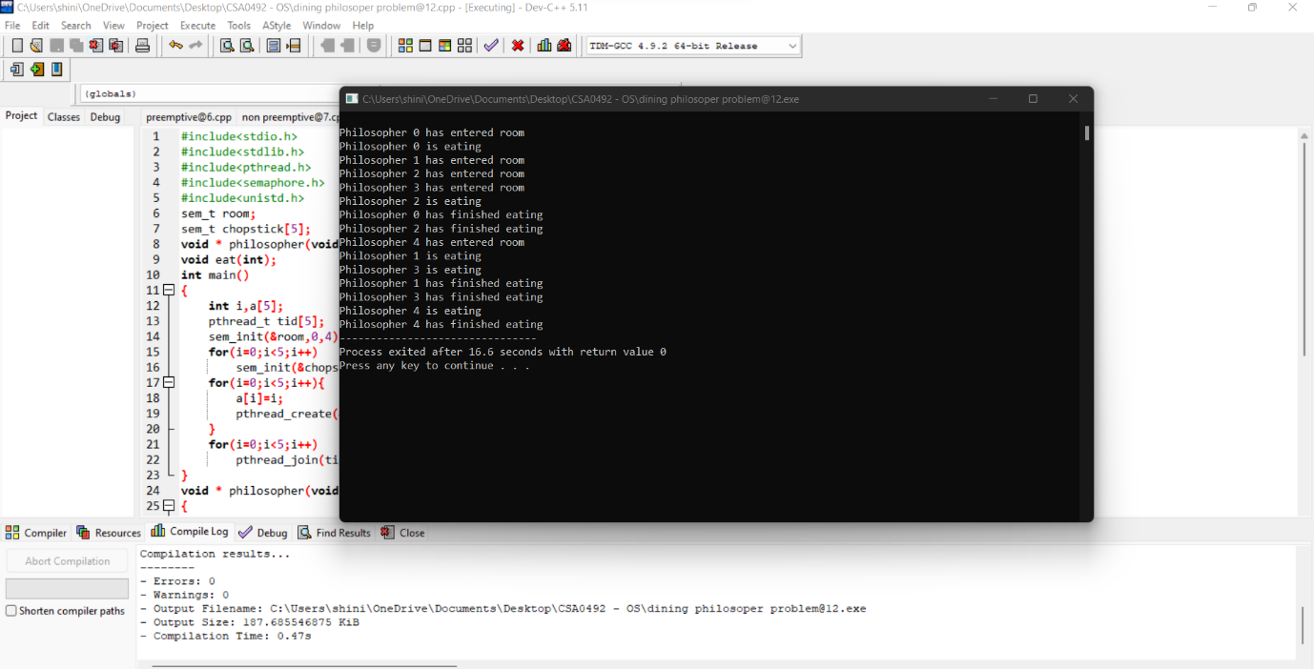

**13.Construct a C program for implementation the various memory allocation strategies.**

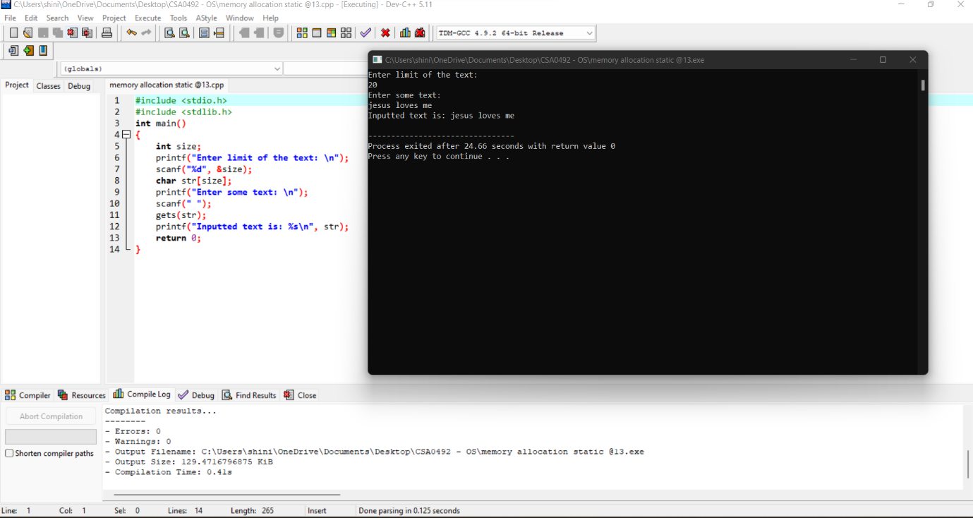

**14.Construct a C program to organize the file using single level directory.**

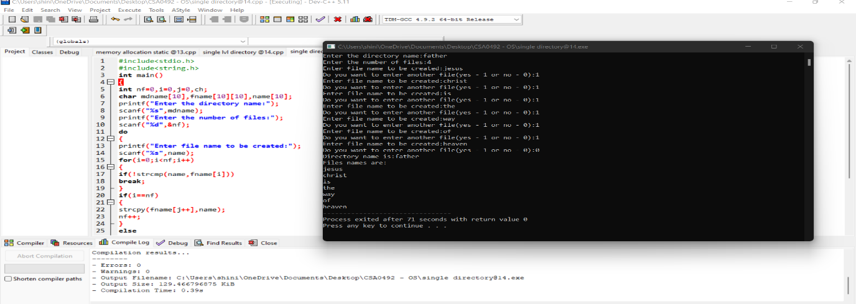

**15.Design a C program to organize the file using two level directory structure**

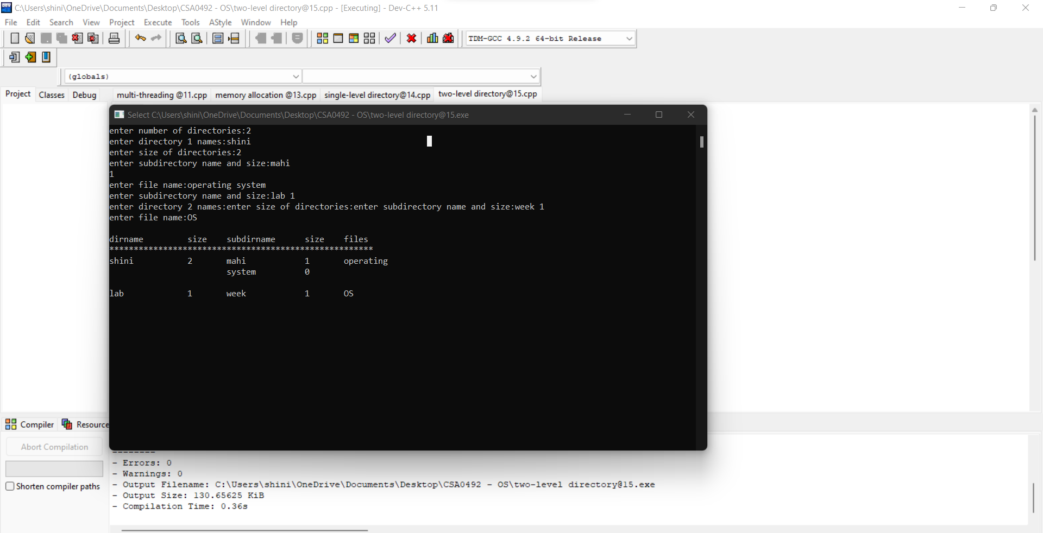

**16.Develop a C program for implementing random access file for processing the employee details.**

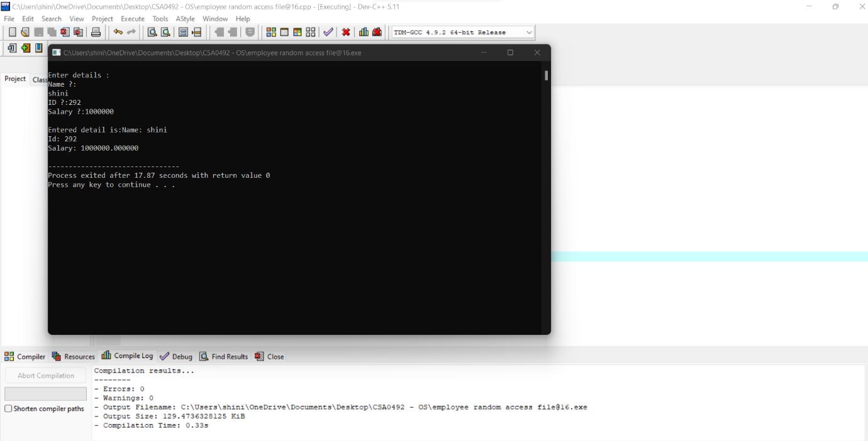

**17.Illustrate the deadlock avoidance concept by simulating Banker’s algorithm with C.**

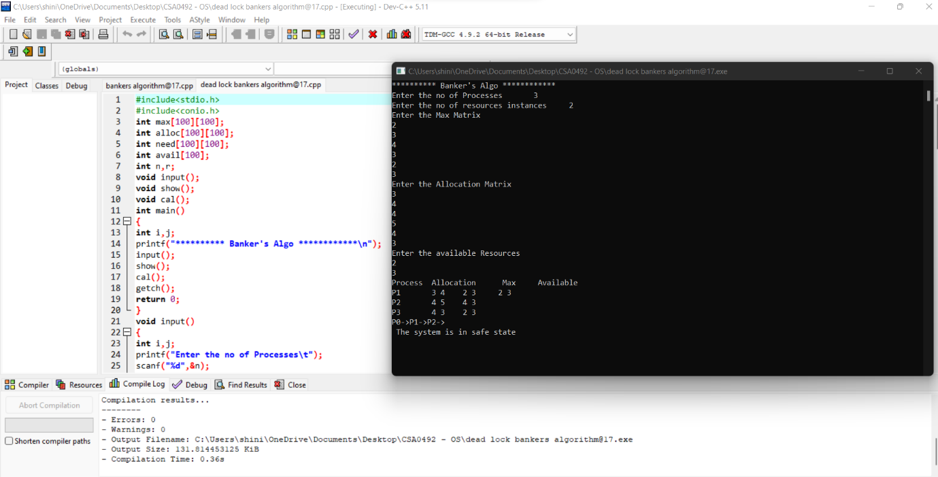

**18 Construct a C program to simulate producer-consumer problem using semaphor**es.

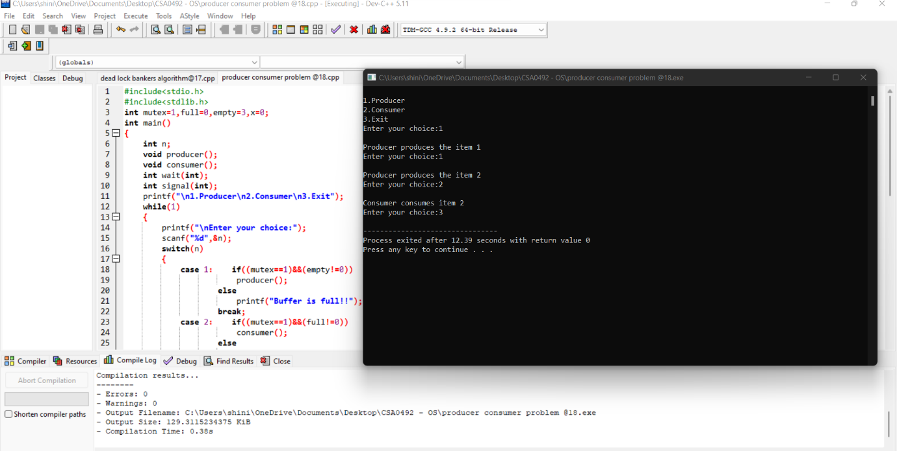

1. **Design a C program to implement process synchronization using mutex locks.**
2. **Construct a C program to simulate Reader-Writer problem using Semaphores.**

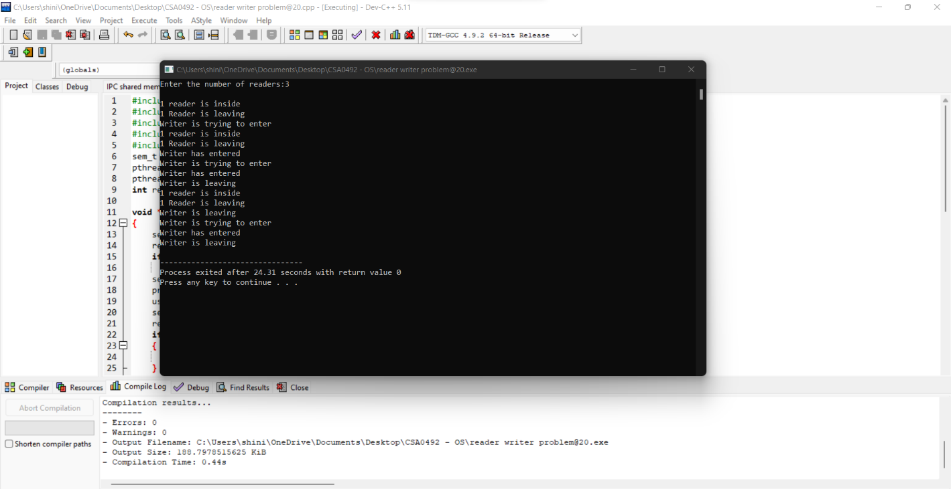

**21.Develop a C program to implement worst fit algorithm of memory management.**

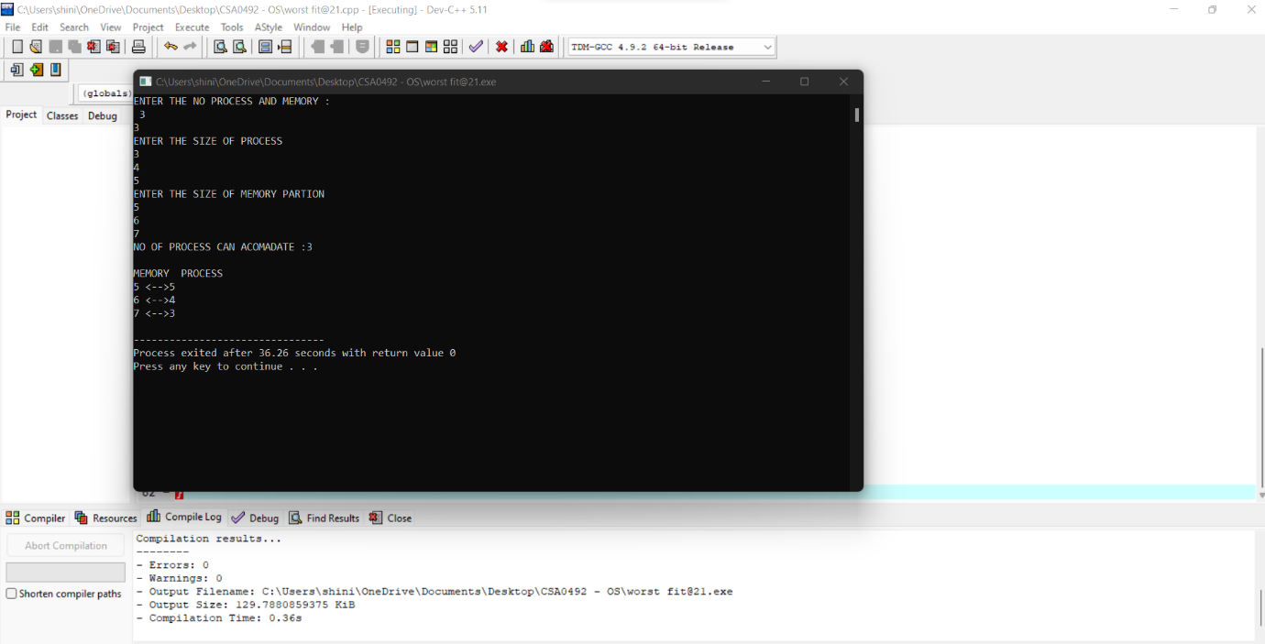

**22.Construct a C program to implement best fit algorithm of memory management.**

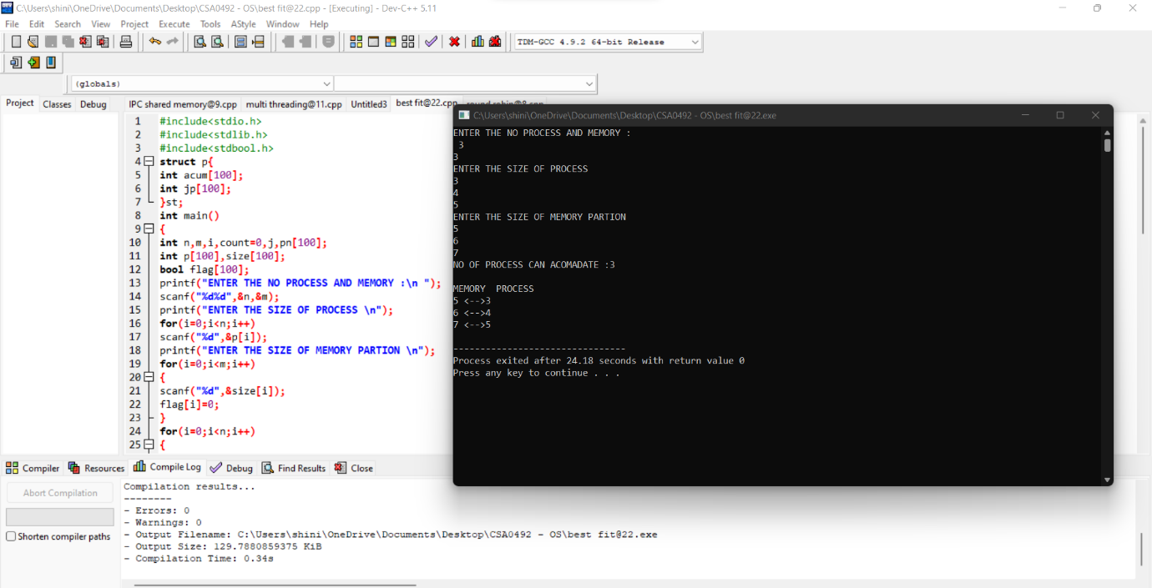

**23.Construct a C program to implement first fit algorithm of memory management.**

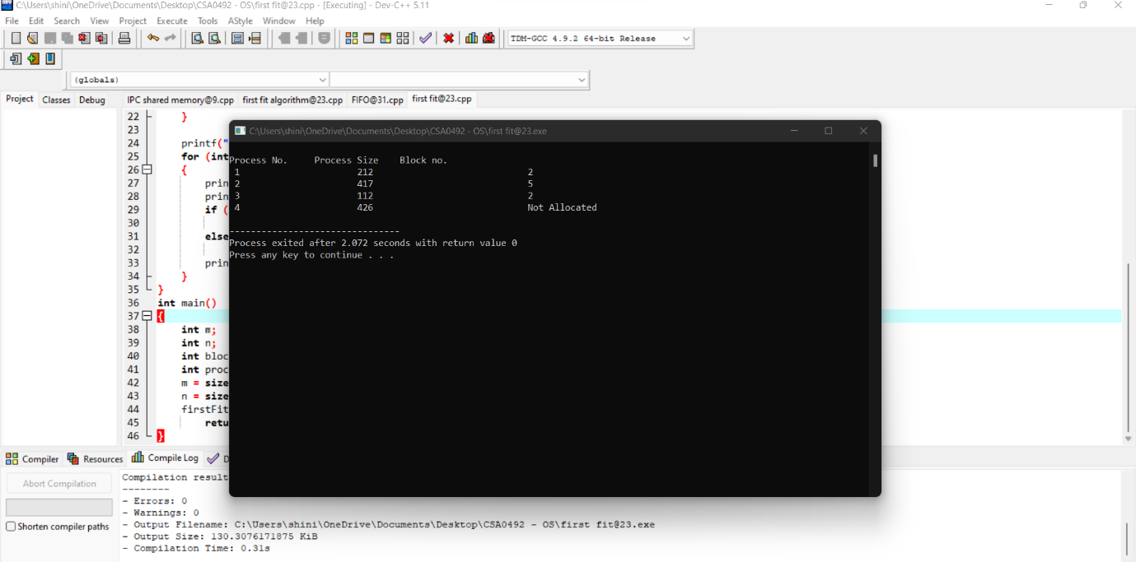

**24.Design a C program to demonstrate UNIX system calls for file management**

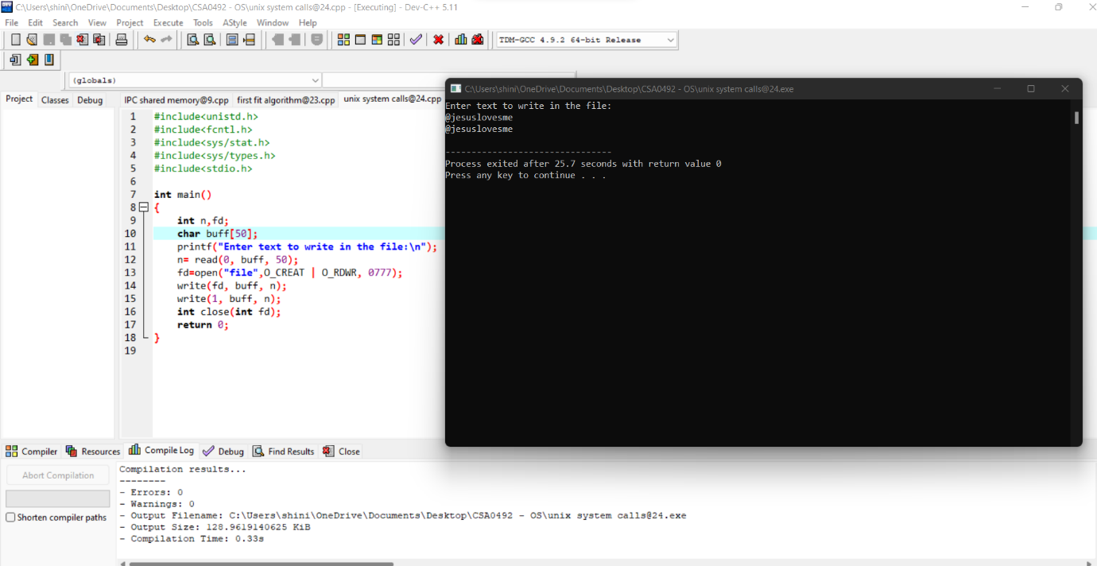

**25.Construct a C program to implement the I/O system calls of UNIX (fcntl, seek, stat, opendir, readdir)**

**26.Construct a C program to implement the file management operations.**

**27.Develop a C program for simulating the function of ls UNIX Command.**

**28.Write a C program for simulation of GREP UNIX command**

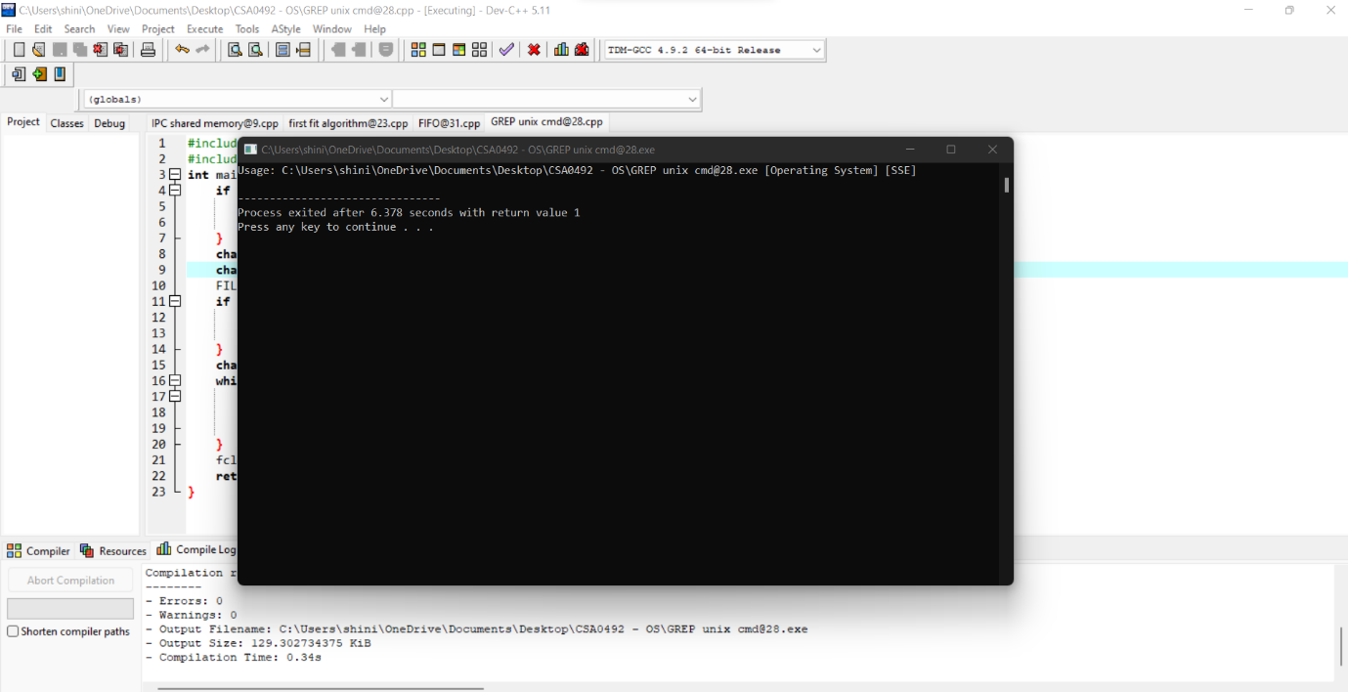

**29.Write a C program to simulate the solution of Classical Process Synchronization Problem**

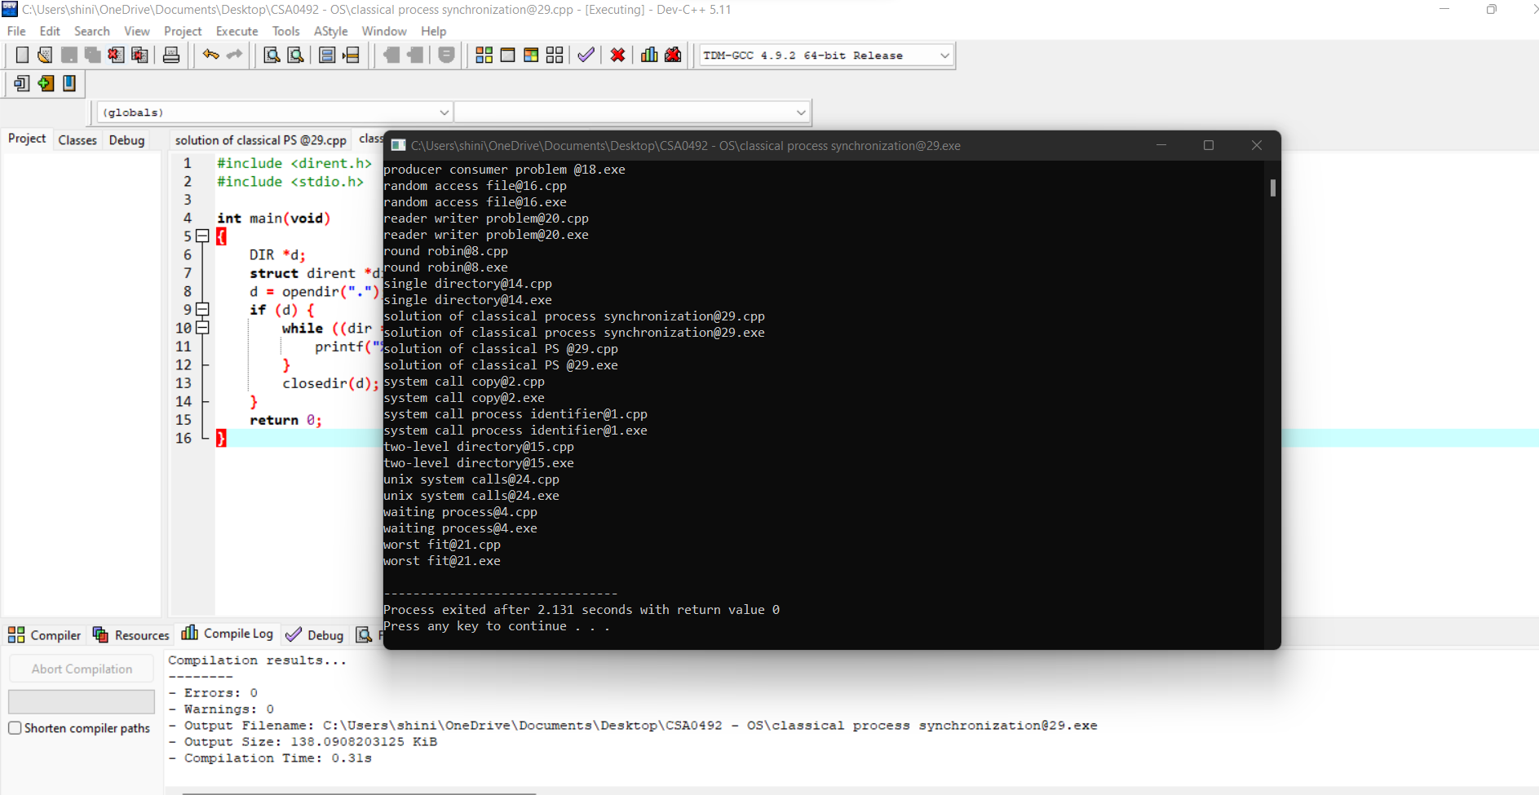

**30.Write C programs to demonstrate the following thread related concepts. (i) create (ii) join (iii) equal (iv) exit**

**31.Construct a C program to simulate the First in First Out paging technique of memory management.**

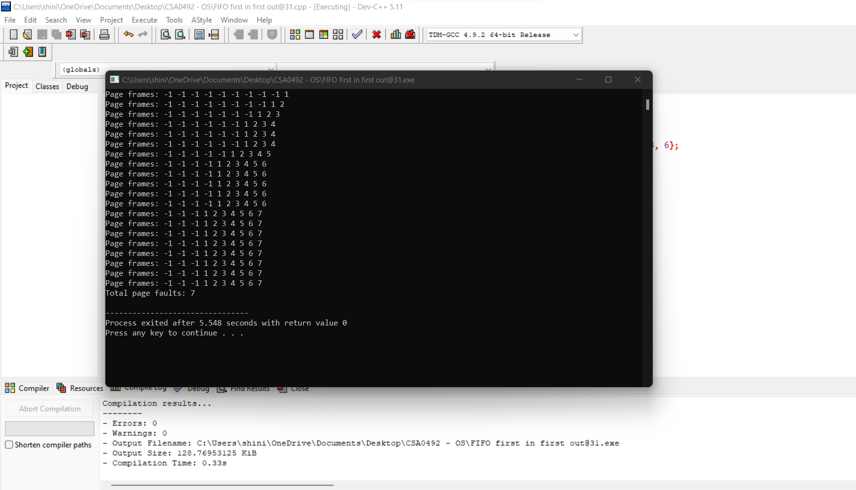

**32.Construct a C program to simulate the Least Recently Used paging technique of memory management**

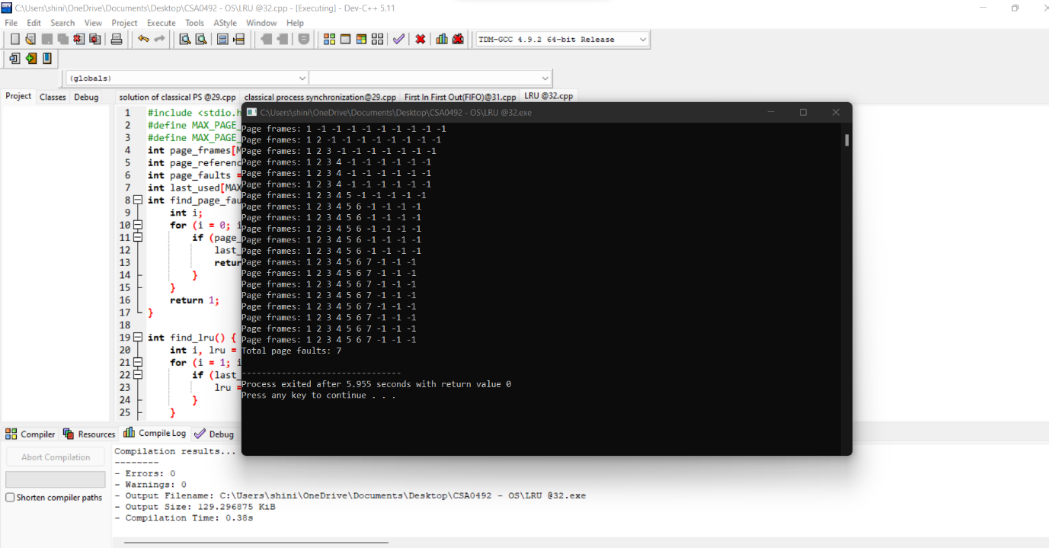

**33.Construct a C program to simulate the optimal paging technique of memory management**

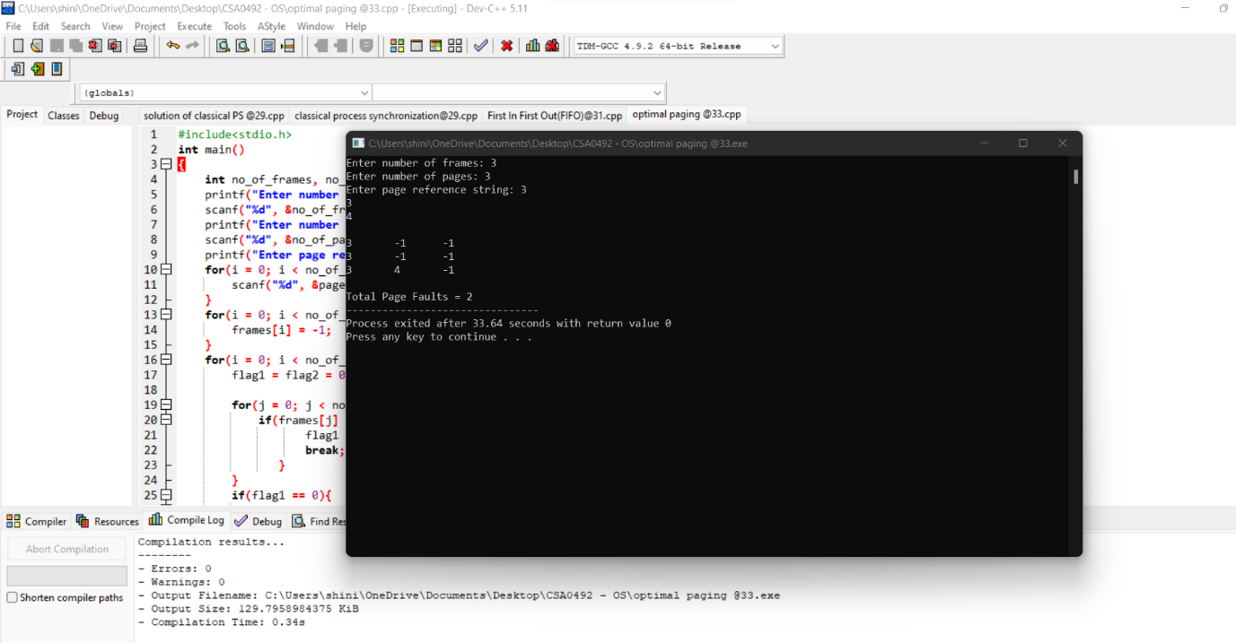 **34.Consider a file system where the records of the file are stored one after another both physically and logically. A record of the file can only be accessed by reading all the previous records. Design a C program to simulate the file allocation strategy.**

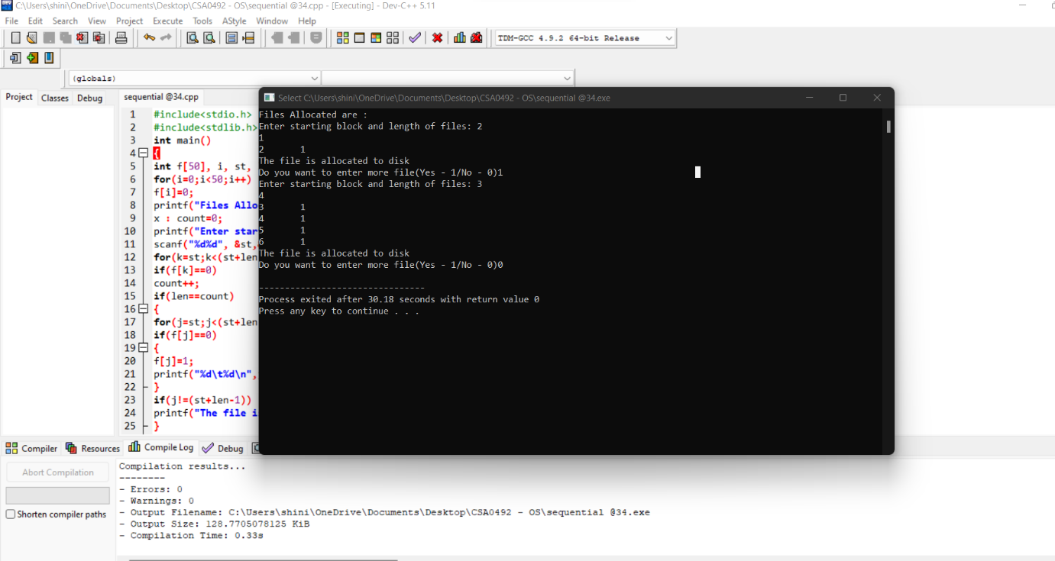

**35.Consider a file system that brings all the file pointers together into an index block. The ith entry in the index block points to the ith block of the file. Design a C program to simulate the file allocation strategy.**

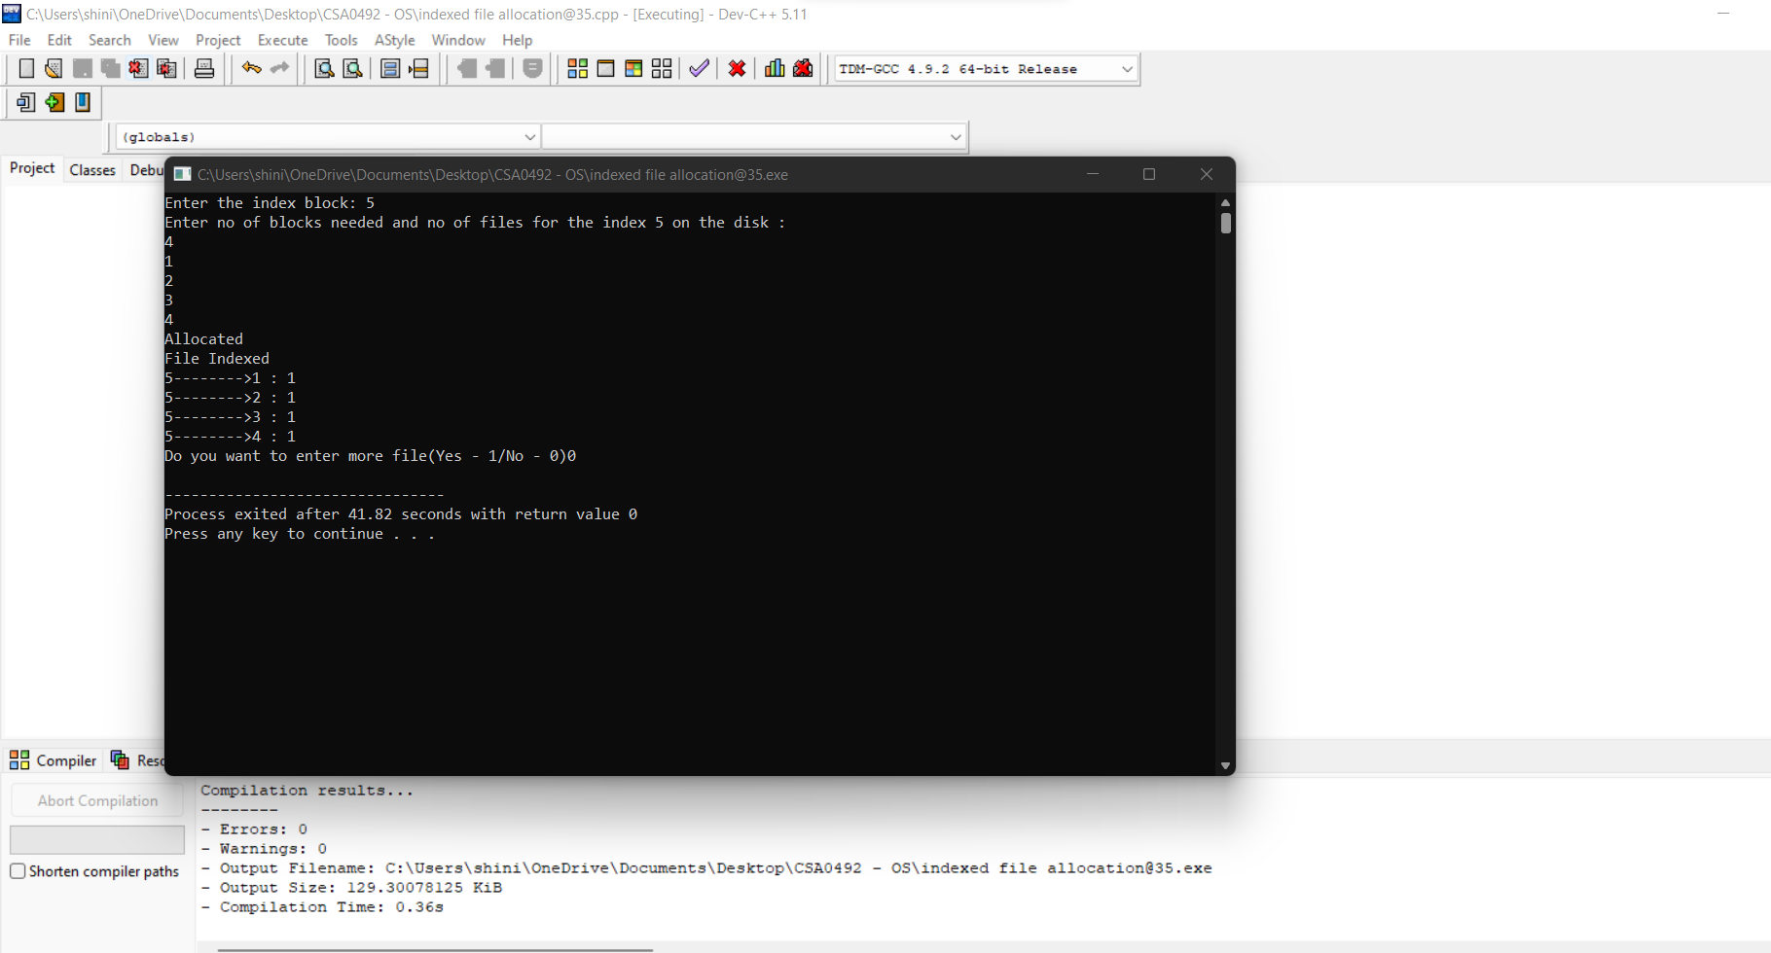

**36.With linked allocation, each file is a linked list of disk blocks; the disk blocks may be scattered anywhere on the disk. The directory contains a pointer to the first and last blocks of the file. Each block contains a pointer to the next block. Design a C program to simulate the file allocation strategy.**

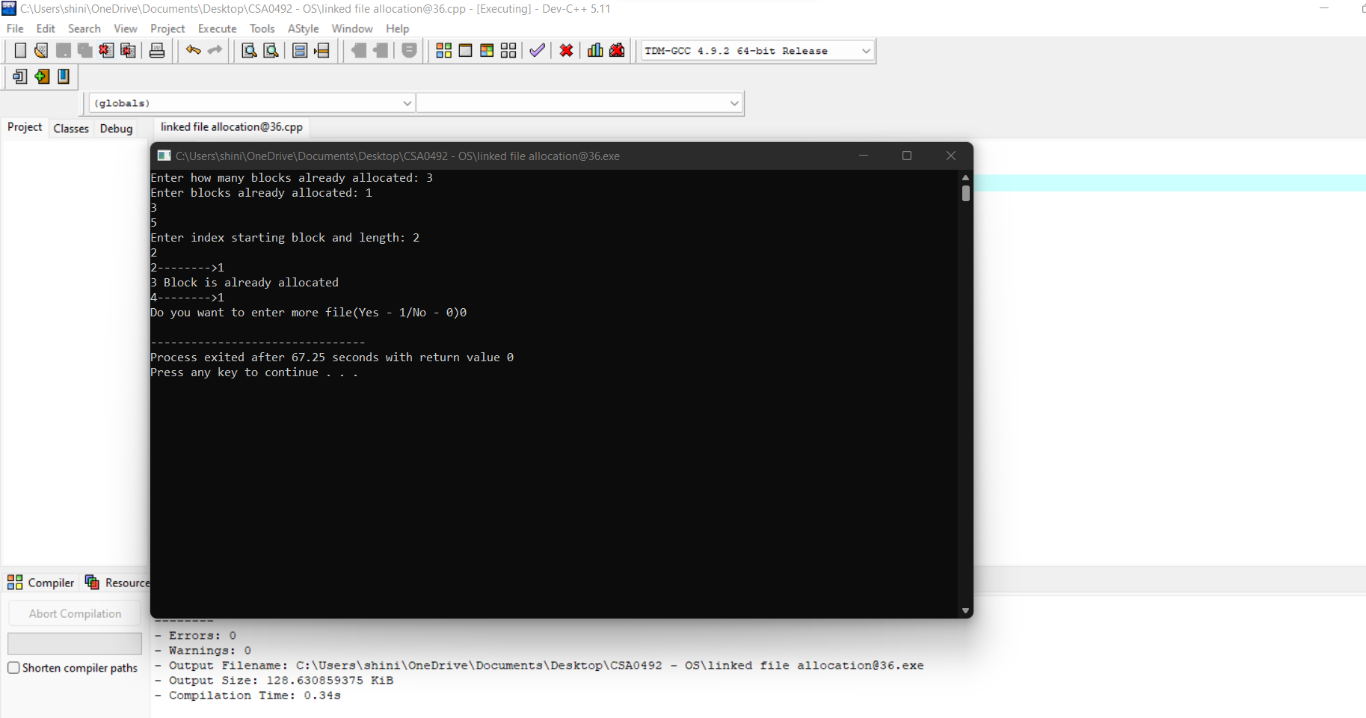

**37.Construct a C program to simulate the First Come First Served disk scheduling algorithm.**

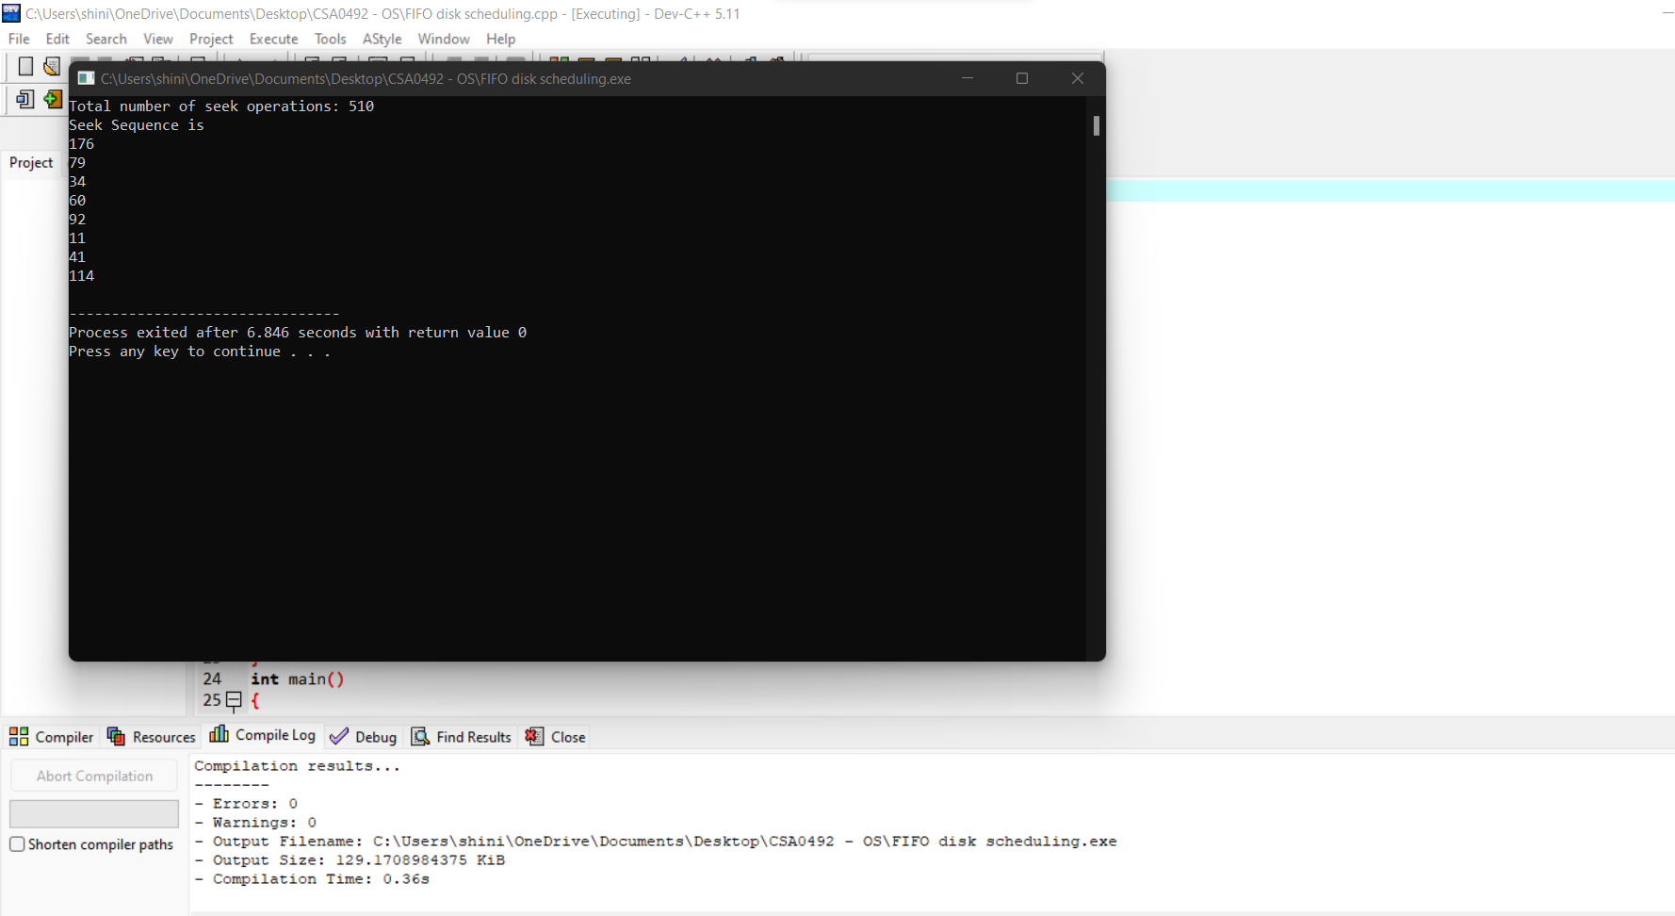

**38.Design a C program to simulate SCAN disk scheduling algorithm.**

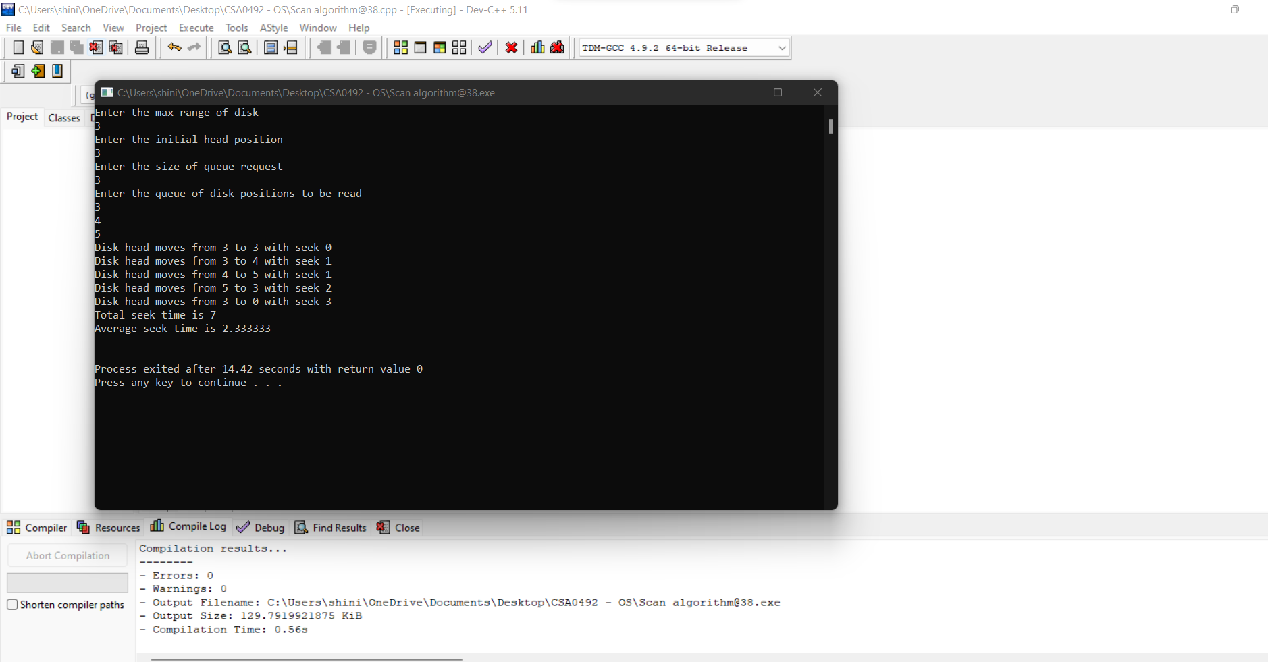 **39.Develop a C program to simulate C-SCAN disk scheduling algorithm.**

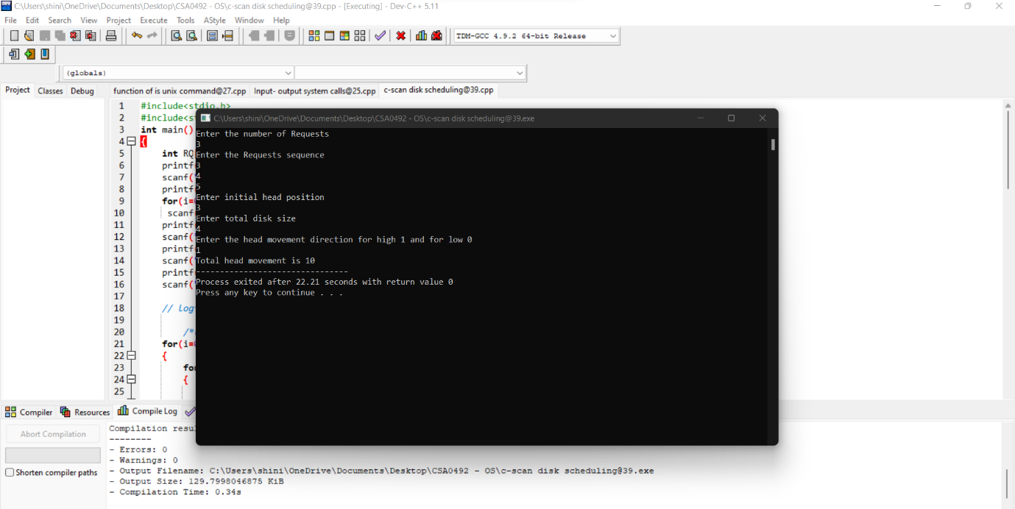

**40.Illustrate the various File Access Permission and different types users in Linux.**